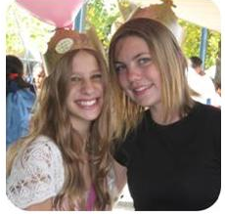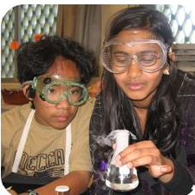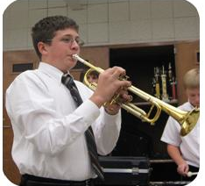

**Parent-Student**

**Visit Dates**

January 9

January 10

January 22

January 23

January 24

January 30

January 31

All visits are

8:30 a.m.-9:30 a.m.

**To schedule a visit**

**Please call**

916-395-5360x407002.



**Enrichment**

* Wolfpack
* Leadership
* Drum line
* Jazz Band
* Sports Teams
* Arts & Crafts
* College Career Labs
* Anime
* Gardening club
* EA Sports club
* Mathletes
* MESA
* Year Book

We invite all 6th grade students and their parents to join us to explore the Sam Brannan campus, visit classrooms and meet our outstanding teachers. Come see why Sam Brannan should be your choice for Middle School. GO WOLFPACK!

## **CALL TODAY AND SIGN UP FOR YOUR VISIT!**

**Academics**

* GATE Program
* CORE Language Arts/History Program
* Mathematics: Math 1,Math 7/8, Math 7,

Math 8.

* Science & Labs
* Computers
* Music: Beginning & Advance Band

**Wolf Pack Top 10**

1. Caring & Dedicated Teachers
2. Rigorous Academic Programs
3. Variety of Elective Offerings
4. Common Assessments in ELA/Math
5. Communication through Infinite Campus
6. Student Activities
7. Award Winning Music Dept.
8. Champion-ship Sports Teams
9. Experimental Learning
10. Exciting Fieldtrips

**Sam Brannan Middle School**

**Parent/Student Visitation Days**

**Sambrannan.scusd.edu**

**Student Life**

* Rallies
* Spirit Week
* School Dances
* National History Day
* Science Fair
* College Fair
* ASES